Assignment 4

Answer 1.

Table No. 1 (Doctor)
CREATE TABLE `Doctor` (
`Did` varchar(10) not null primary key,
`DFirstName` char(20) not null,
`DLastName` char(20),
`DSex` char(1) not null,
`DQualification` char(10),
`DContact` integer check(`DContact`<9999999999 and ` Dcontact`>0000000000))


Table No. 2 (Patient)
CREATE TABLE Patient(
PId varchar(20) not null primary key,
PFirstName char(10) not null,
PLastName char(20),
PAddress varchar(50) not null,
PDateOfBirth date,
PDiagnosis varchar(50),
PContact integer check(PContact <=9999999999 and PContact >=0000000000))


x

Table No. 3 (Hospital)
CREATE TABLE `Hospital` (
`HName` char(20) not null primary key,
`HCity` char(20) not null,
`HAddress` varchar(50))



Table No. 4 (Medical Record)
CREATE TABLE "MedicalRecord" (
"PId" varchar(10) NOT NULL,
"Problem" varchar(50) NOT NULL,
"DateOfExamination" date,
PRIMARY KEY("Pid"))


Table No. 5 (Nurse)
CREATE TABLE `Nurse` (
`NId` varchar(10) not null,
`NFirstName` char(20) not null,
`NLastName` char(20),
`NSalary` integer,
`NContact` integer check (`NContact`<=9999999999 and `NContact` >=0000000000))



Answer 2.a Query and it’s result for my Table are

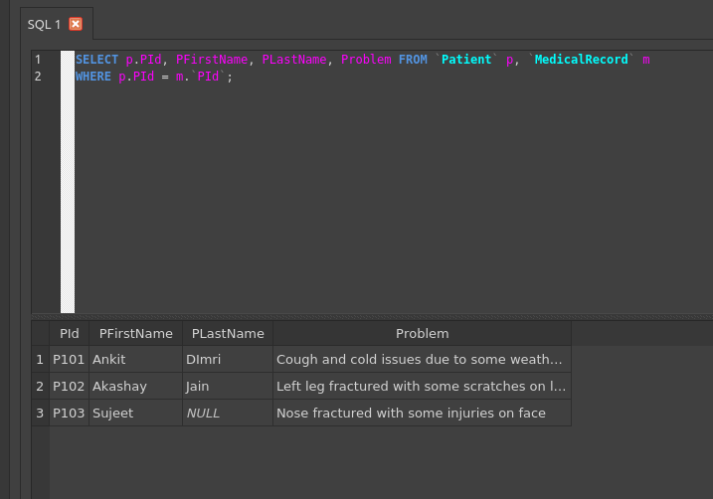

Answer 2.b Query and result for my table are


